Course-End Project
Analyzing Customer Orders Using Python

Overview

In this project, you will analyze customer orders using Python data structures to classify products, identify customer purchasing patterns, and generate business insights. This analysis will help you understand which products are most popular, which customers are high-value, and how purchase behavior varies across different categories. You will leverage lists, tuples, dictionaries, and sets, along with loops and conditionals, to process and organize customer order data efficiently.

Instructions

Submission: Submit a comprehensive report including customer classification, product category analysis, and key business insights

Tools: Python (for data processing and analysis)

Dataset: A predefined set of customer orders (stored in lists, tuples, and dictionaries)

Situation

You are working as a data analyst for an e-commerce company. Your task is to process and analyze customer orders to generate meaningful insights. Your company sells a variety of products across different categories, such as Electronics, Clothing, and Home Essentials. You need to determine which products are frequently purchased, classify customers based on their total spending, and analyze the most profitable product categories.

To achieve this, you will store, categorize, and analyze customer purchase data using Python's built-in data structures (lists, tuples, dictionaries, and sets) and control structures (loops and conditionals). The final output will help business managers make data-driven decisions regarding marketing strategies and inventory management.

Tasks

1. Store customer orders
- Create a list of customer names
- Store each customer's order details (customer name, product, price, category) as tuples inside a list
- Use a dictionary where keys are customer names and values are lists of ordered products
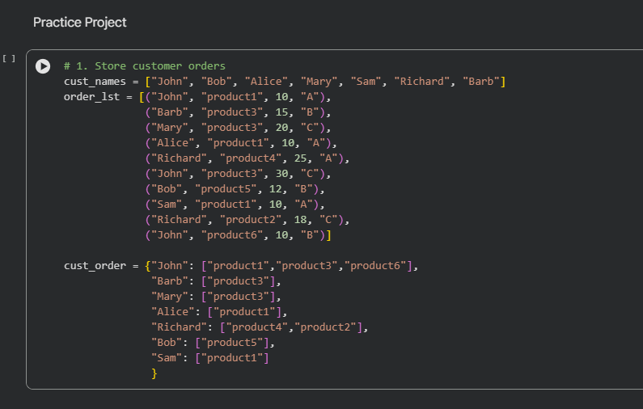

2. Classify products by category
- Use a dictionary to map each product to its respective category
- Create a set of unique product categories
- Display all available product categories
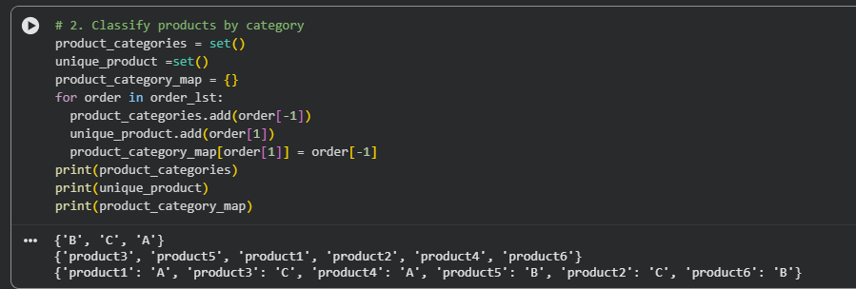

3. Analyze customer orders
- Use a loop to calculate the total amount each customer spends
- If the total purchase value is above $100, classify the customer as a high-value buyer
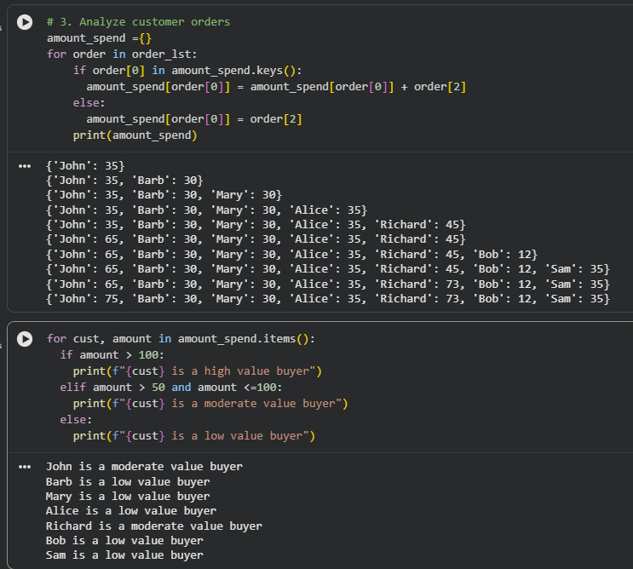
- If it is between $50 and $100, classify the customer as a moderate buyer • If it is below $50, classify them as a low-value buyer

4. Generate business insights
- Calculate the total revenue per product category and store it in a dictionary
- Extract unique products from all orders using a set
- Use a list comprehension to find all customers who purchased electronics
- Identify the top three highest-spending customers using sorting
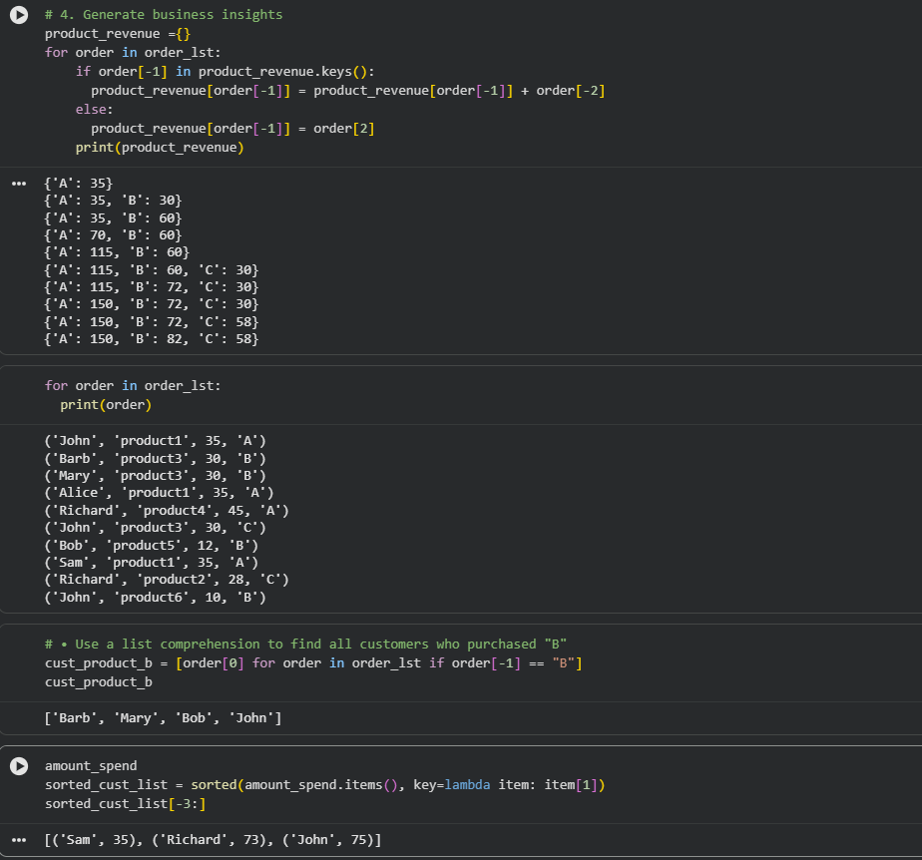

5. Organize and display data
- Print a summary of each customer’s total spending and their classification
- Use set operations to find customers who purchased from multiple categories
- Identify common customers who bought both electronics and clothing

Actions

Customer order processing in python
- Store customer order data using lists, tuples, and dictionaries
- Retrieve and modify customer records using dictionary methods

Classification and analysis
- Use loops to categorize customers based on their total spending
- Use set operations to find common and unique products across different categories

Insight generation
• Extract the high-value customers and most frequently purchased products • Identify trends based on category-wise sales

Result

The final deliverable will be a detailed report summarizing customer classifications, total sales per category, and key insights about purchase behavior. This project demonstrates how Python’s data structures can be used to analyze real-world e-commerce data, helping businesses make informed decisions.

Project Link: https://colab.research.google.com/drive/1UC2Y-c2FKuvTmzCf1MsspHQ2x7nwk2pw?usp=sharing

